Unit One Study Guide

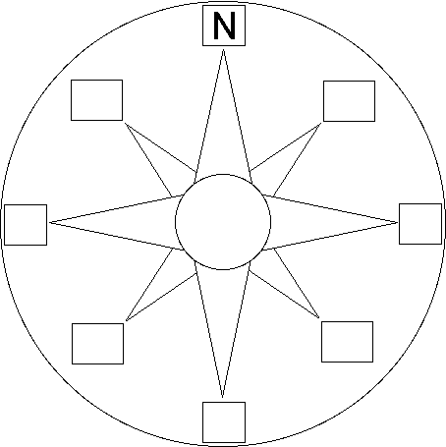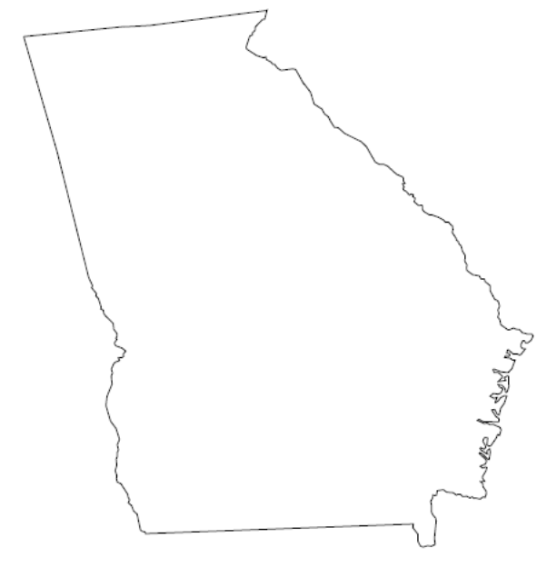Directions: On the map label the following:

1. Cardinal direction on the compass rose
2. Blue Ridge Region
3. Valley and Ridge Region
4. Appalachian Plateau Region
5. Piedmont Region
6. Coastal Plain
7. Chattahoochee River
8. Barrier Islands
9. Okefenokee Swamp
10. Fall Line
11. Tybee Island
12. Cumberland Island
13. Appalachian Mountains
14. Atlanta
15. Columbus
16. On the map Label Georgia and the states that border Georgia.

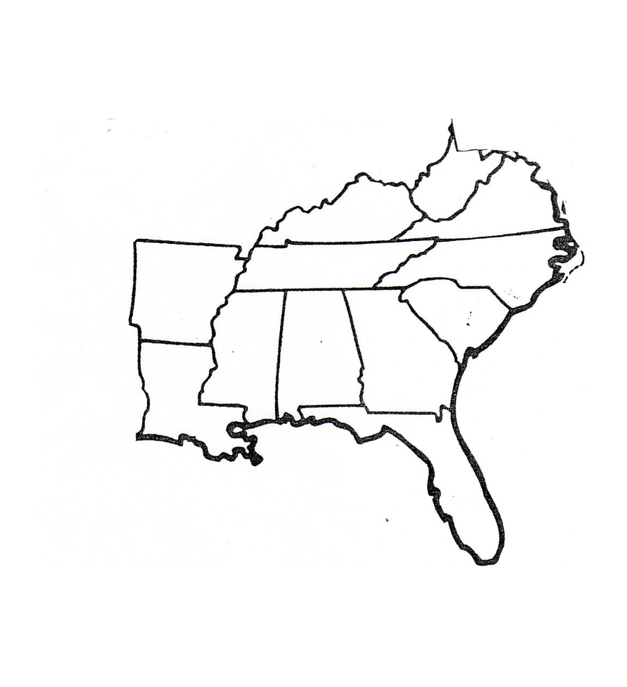

1. In which region of the U.S is Georgia located?
2. **What characteristics do the mountain regions of Georgia (Appalachian Plateau, Valley and Ridge, and Blue Ridge) have in common?**
3. How many barrier islands are there?
4. What is Georgia’s prehistoric shoreline called?
5. What are Georgia’s two major rivers, and in which region do they originate?
6. Describe the climate of each region.

|  |
| --- |
| * Appalachian Plateau |
| * Valley and Ridge |
| * Blue Ridge |
| * Piedmont |
| * Coastal Plain |

1. Describe the economic contributions of each region.

|  |
| --- |
| * Appalachian Plateau |
| * Valley and Ridge |
| * Blue Ridge |
| * Piedmont |
| * Coastal Plain |

1. In what region is the “Carpet Capital of the World” located in?
2. What are the physical characteristics of the Coastal Plain?
3. What major cities are located in the Piedmont region?
4. Which barrier island is farther north? Which barrier island is farthest south?
5. Which river forms Georgia’s southwestern border?
6. Which river forms Georgia’s eastern border?
7. Which river is the Piedmont region’s primary water source?
8. **Which states are part of the Tristate Water War?**
9. Why are businesses attracted to Georgia?
10. **What is the chronological order of Georgia’s prehistoric natives (Woodland, Mississippian, Archaic, Paleo)?**
11. **Why do archaeologists believe that the Paleo natives were nomadic hunters?**
12. What kind of town did Mississippians live in?
13. How were Mississippian villages organized?
14. How was Mississippian society structured (who was at the top, middle, and bottom)?
15. **What impact did the Spanish have on Native Americans?**