**Let’s Explore Georgia Map Activity**

**Instructions**: Use the map to explore Georgia and answer the questions below. Highlight your answers in a color to make it easier for teacher to find.

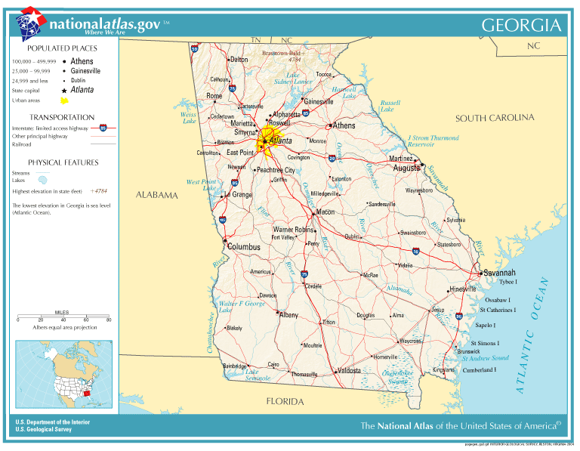

1. Look at the KEY and find the symbol for Interstate Highway. What **3** highways **go directly** into Atlanta?

6. Find Georgia’s barrier islands. There are 15 total. Can you name 5 of them?

2. Look the KEY to find the symbol for “Physical Features.” What 2 main physical features does the map show? Can you name 3 specific features named on the map?

7. If I were to travel from Savannah to Atlanta, the capital of Georgia, what highway would I take?

8. What 5 states border Georgia?

3. Can you name 4 rivers found on the map? What 2 rivers are part of Ga.’s border?

9. Brasstown Bald is the highest point in Georgia. What is its elevation? (Find Brasstown Bald to find it).

4. Georgia’s rivers have many tributaries that feed into it, which creates larger rivers. These large rivers are often damned up to create lakes for drinking water, hydropower, and recreation. Can you find at least 4 lakes on the map? What rivers are used to create the lakes you found?

10. What 2 – 3 interesting observations can you find from studying the map? Be detailed.

8. The Savannah River begins in the area of Lake Hartwell. Can you find it on the map? Follow the Savannah River all the way (301 miles) to the end. What major town can be found at its end? What ocean does it empty into?

5. The **Chattahoochee** River begins as a small stream in North Georgia but picks up strength as many tributaries feed into it. It eventually empties into the Gulf of Mexico. Find Blairsville in North Georgia, as this is general area where the Chattahoochee begins. Look south of Blairsville to find a large lake that uses the waters of the Chattahoochee. What is the name of the lake? What is the name of the city that can be found here?